**Day 6 - Deployment & Staging Environment Setup:**

**Objective:**

*Day 6 is dedicated to getting your marketplace ready for deployment. This involves setting up a staging environment, configuring hosting platforms, and ensuring the application is prepared for customers. Building on the testing and optimization completed on Day 5, this stage ensures that the marketplace functions smoothly in a production-like environment.*

1. ***Deployment Strategy Planning:***

*For deployment, I have chosen Vercel as the hosting platform. Vercel provides various advantages, including seamless integration, automatic scaling, and a developer-friendly experience, making it an excellent choice for modern applications.*

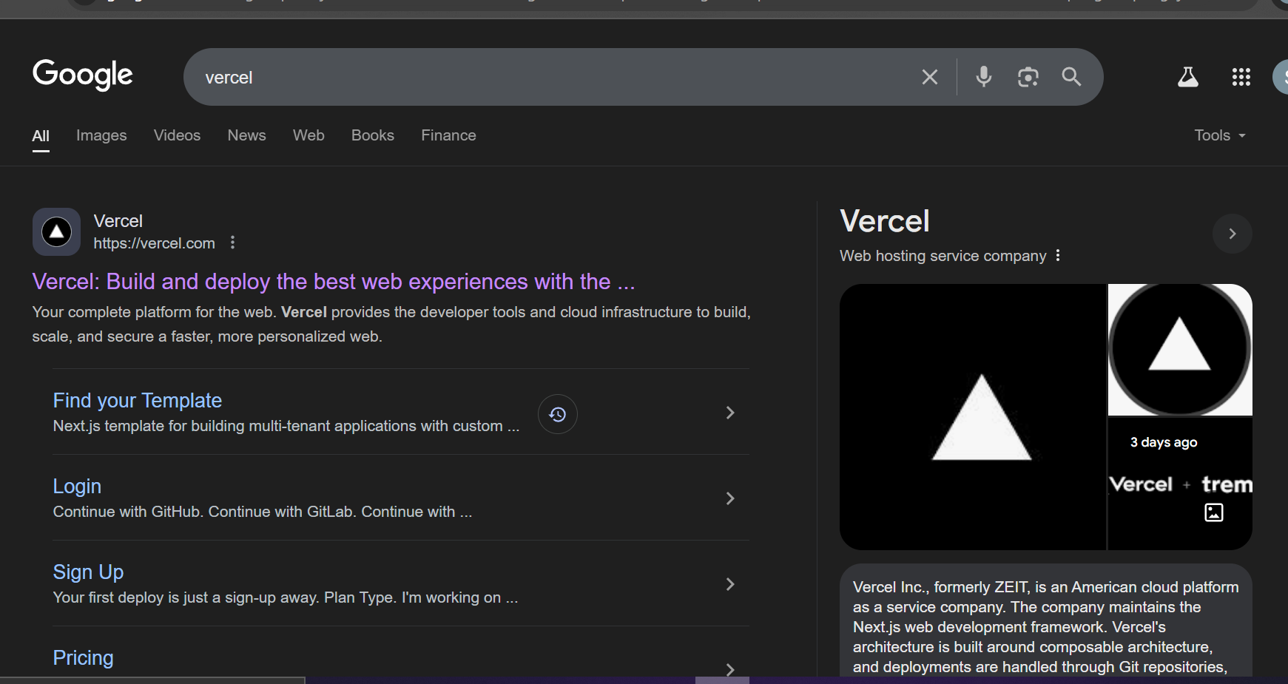

***2. Staging Environment Setup***

*Deploy the application to a staging environment to test it in a production-like setting. The deployment build completed successfully without any errors and application loaded correctly in browser*

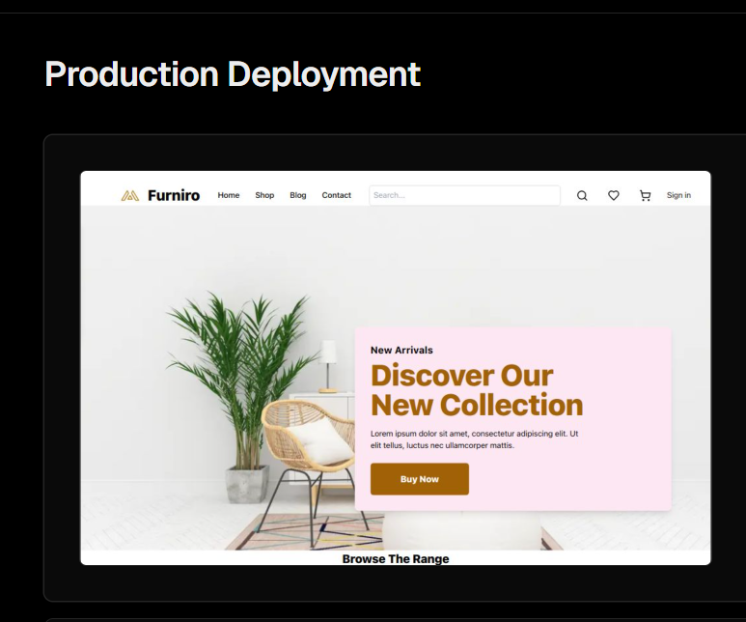

***3.Configure Environment Variables:***

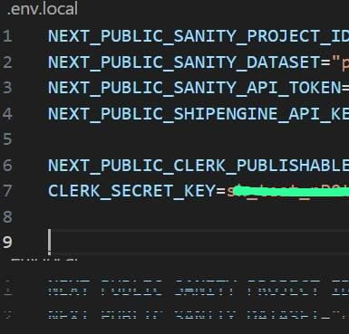

***4. Github:***

